**DBMS Keys :**

A DBMS key is an attribute or a set of attributes which help you uniquely identify a record or a row of data in relation(Table).

Types of Keys :

1. Primary key
2. Composite key
3. Candidate key
4. Alternate key
5. Super kye
6. Foreign key
7. Unique key
8. Primary Key : Primary key is a candidate key that is most appropriate to become the main key for any table. It is a key that can uniquely identify each record in a table.

Primary key is choosen from set of candidate keys.

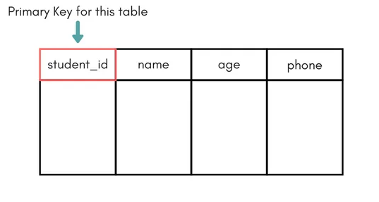

1. Composite key : A composite key is a combination of two or more columns in a table that can be used to uniquely identify each row in a table.

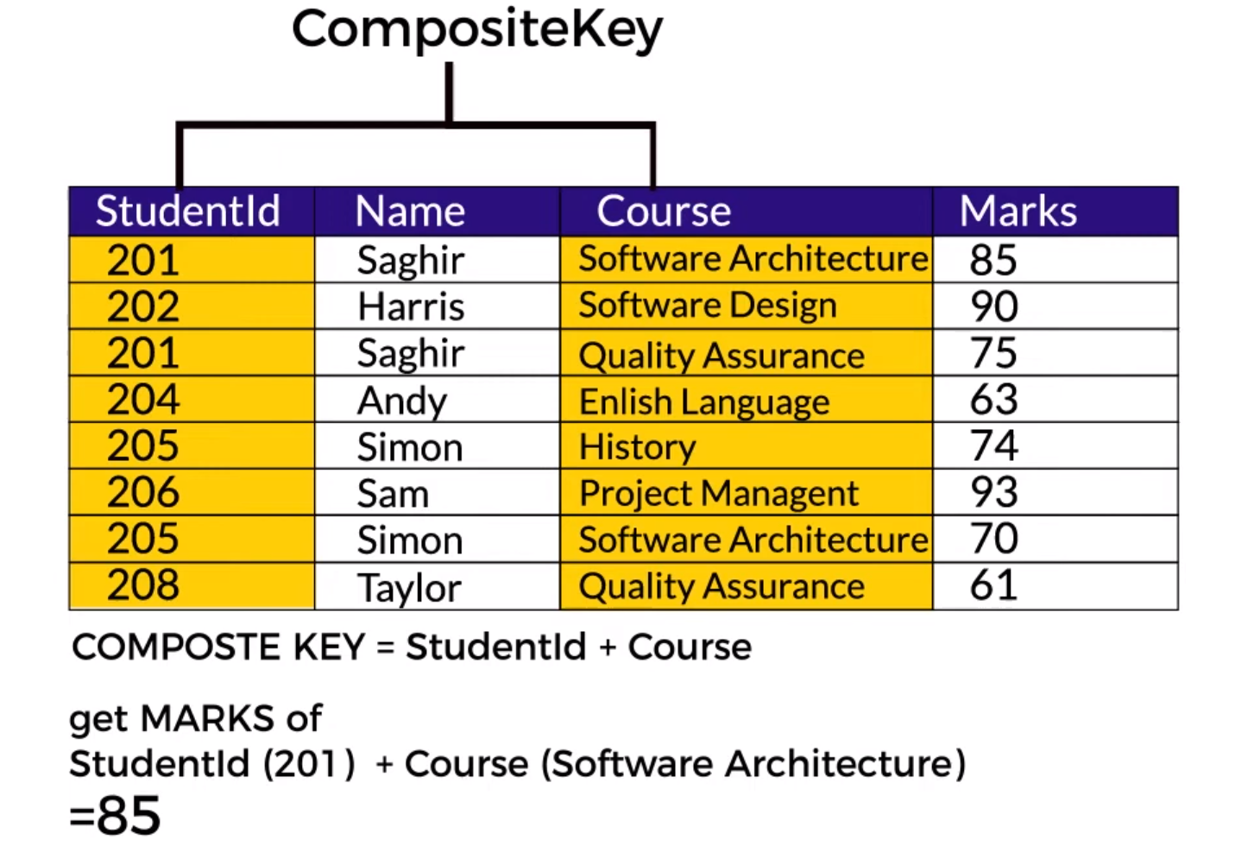

1. Candidate key : A candidate key SQL is a column or a set of columns that can qualify as a primary key in the database. There can be multiple SQL candidate keys in a database relation and each candidate can work as a primary key for the table.
2. Alternative key or Secondary key : The candidate key which are not selected as primary key are known as secondary keys or alternative keys.

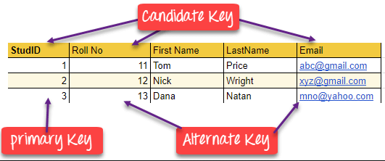

1. Super Key : A super key is a combination of all possible attributes which can uniquely identify two tuples in a table . or Super set of any candidate key is a super key.

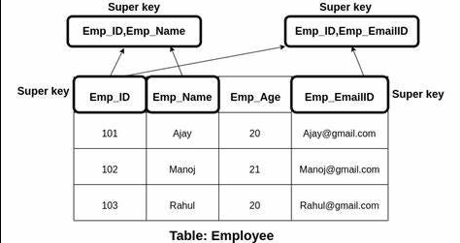

f ) **Foreign key :** foreign key is the one that is used to link two tables together or create connectivity between the two.

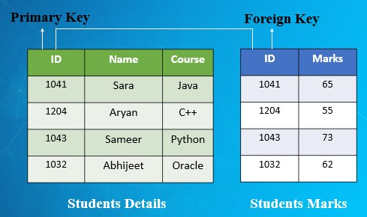

G ) Unique key : Unique Key is a column or set of columns that uniquely identify each record in a table.

It can have one null value but primary key can not have any null value.

1. **DML Commands ( Data Manipulation Language ) :** Used to manipulate the data present in Table/Relation.

Type of DML commands :

1. Insert
2. Update
3. Select
4. Delete

A ) Insert Syntax: - INSERT INTO table_name VALUES (value1, value2, value3);

B ) Update Syntax : - UPDATE table_name SET column1 = value1, column2 = value2,…

C ) Select Syntax :- Select * from table name;

D ) Delete Syntax :- DELETE FROM table_name WHERE some_condition;